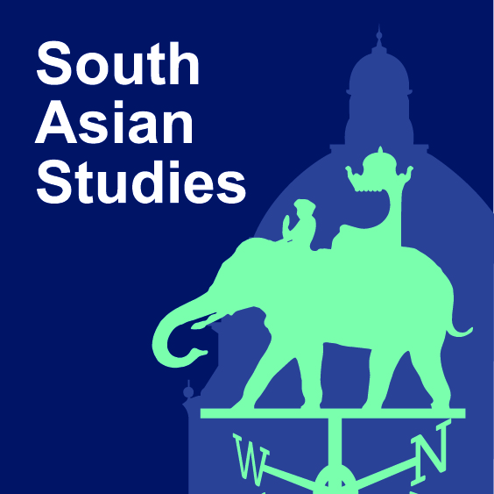
Charles Wallace Trust Fellowship
Academic Visitor Programme for Pakistan
Application Form

Guidance Notes
The Charles Wallace Pakistan Trust will sponsor one scholar or practitioner from Pakistan as a visitor to the University of Oxford’s Contemporary South Asian Studies Programme (CSASP) at the Oxford School of Global and Area Studies (OSGA) in Trinity term (25 April – 19 June 2020).

The fellowship will enable a Pakistani academic or professional to undertake a short working visit to the CSASP with the aim of broadening their research experience, sharing their professional knowledge, and developing networks. Academic applicants must hold a PhD. Professional applicants must have at least five years’ relevant experience.

The successful applicant will be expected to undertake an independent research project and contribute to the life of the School during their time at CSASP.

To apply for the Charles Wallace Trust Academic Visitor Programme for Pakistan, applicants must complete this form and submit it by email together with a current copy of their curriculum vitae to the CSASP Administrator on south.asia@area.ox.ac.uk by Tuesday 31 December 2019. Please note that two letters of reference are required and these should be sent by email to the same address by the same deadline.

A - Personal Details
Title: Click here to enter text. | Surname: Click here to enter text.
Forename(s): Click here to enter text.
Home Institution/Place of Work: Click here to enter text.

Position: Click here to enter text.
Correspondence address: Click here to enter text.

Email address: Click here to enter text.
Nationality: Click here to enter text. |  | Country of residence: Click here to enter text.
B - Details of planned visit
Dates of visit: Choose an item.

If you already have an association with an Oxford College, please state which College: Click here to enter text.

C – Research Proposal
Research Proposal (max 1000 words): Please give here details of your proposed independent study project and the specific ways in which affiliation to CSASP/OSGA would assist with this.

Click here to enter text.

Your contribution to CSASP/OSGA: Please give here information on what contribution you would make to the School if appointed, for example by delivering a research seminar, organising an event or developing a publication, as well as mentoring students studying Pakistan as applicable.

Click here to enter text.
Please give brief details of your area(s) of expertise: Click here to enter text.
D – Referees
Please give details below of two referees. You should ask the referees to send their references on institutional letterhead by email attachment directly to the CSASP Administrator on south.asia@area.ox.ac.uk to arrive by the closing date of 31 December 2019.
Referee 1  Name: Click here to enter text.  Position: Click here to enter text.  Institution: Click here to enter text.  Postal address: Click here to enter text.  Official email address: Click here to enter text.  Telephone number: Click here to enter text. |  |  | Referee 2  Name: Click here to enter text.  Position: Click here to enter text.  Institution: Click here to enter text.  Postal address: Click here to enter text.  Official email address: Click here to enter text.  Telephone number: Click here to enter text.
E – Agreement
I confirm that if accepted as an Academic Visitor by The Oxford School of Global and Area Studies (OSGA)/The Contemporary South Asian Studies Programme (CSASP), I agree to follow the School’s Policy and Procedure for Visiting Academics.

I understand that I will be issued with a University card and email address. Desk space at OSGA will normally be provided but at times of high demand cannot be guaranteed.

I understand that the School cannot arrange accommodation for me but will offer guidance on finding privately rented accommodation.

Signed:

Date:

